GCIS 124 – Final Exam

Name: _______________________________ Last Commit Time: __________

Read This First
- You may use the following on your exam:
  - myCourses (browser)
  - GitHub/GitHub Classroom (browser)
  - Your 8.5 x 11" (standard A4 letter sized), double-sided sheet of handwritten notes
  - VS Code with only the Final Practicum repository opened
  - The terminal inside of VS Code
- You may not have access to any of the following during the exam (initial each to indicate that you understand):
  - Any other website.
  - Any AI tool enabled in your IDE (including co-pilot).
  - Any lecture slides, videos, notes, etc. beyond your handwritten sheet of notes.
  - Any other code or repositories (e.g., Unit 06 repository).
  - Anything not mentioned here that you should understand is prohibited during an exam.
  - Violating any of the above will result in a minimum grade of 0 on the exam.
- When you open your repository, you may be prompted with the following dialog; click the Allow and Run. If you accidentally disable the task or auto-commit is not running, raise your hand immediately
- Using any kind of AI tool to generate code during this exam will result in an F in the course. No questions, no excuses, no second chances.
- Before leaving the room, confirm your solutions is pushed on GitHub, quiz submitted in myCourses, and hand in this packet. Not handing in this packet will result in a 0 on the exam
- Do not access Git repository or Quiz after you leave the classroom. Any indication of access will result 0 on the exam.

Question 1 – Car Wash Station (35)
A Car Wash Station has a limited number of washing bays. Cars arrive and must wait if no bay is available.
A CarWash class is provided. DO NOT MODIFY IT.

Available methods:

hasBay() → returns true if a washing bay is available
- enter(String carId) → assigns a bay to the car
- exit() → frees a bay

Part A – Create a Car Class
Create a Car class and make it a thread.
Note: An empty Car class is provided to you.

Attributes:
- carId (String)
- washTime (int, seconds)
- carWash (CarWash)
- Any additional synchronization objects needed

Constructor
- Initialize all fields

run() method Implementation:
Each car should:
- Print: "Car <id> arrives"
- Wait for all cars to be ready using CountDownLatch
- Try to enter:
  - If no bay available
      - Print “Car <id> waiting for bay”
      - wait using Condition
  - Recheck condition after waking
- When a bay is available:
  - Call enter()
  - Print: "Car <id> starts washing for <time> sec"
- Sleep for washTime × 1000
- Call exit()
- Notify waiting cars
- Print: "Car <id> leaves"

Part B — Main Method
Note: An CarWashMain class with empty main method class is provided to you.
Write a main method:
- Create:
  - CarWash with 2 bays
  - CountDownLatch for all cars
  - Shared Lock and Condition
- Create 5 cars:
  - Unique IDs: C1–C5
  - Random wash time between 1–3 seconds
- Use ExecutorService to:
  - Start all cars concurrently
- Print:
  - "Car wash is open!" after all threads start
- Wait for all threads to finish
- Print:
  - "Car wash is closed"
Note: Your solution should use the following java items:
- Lock
- Condition
- CountDownLatch
- ExecutorService

Example Output
Note: that sequence of output may be in different
Car C1 arrives
Car C2 arrives
Car C3 arrives
Car C4 arrives
Car C5 arrives
Car wash is open!
Car C1 starts washing for 2 sec
Car C2 starts washing for 1 sec
Car C3 waiting for bay
Car C4 waiting for bay
Car C5 waiting for bay
Car C2 leaves
Car C3 starts washing for 3 sec
Car C1 leaves
Car C4 starts washing for 1 sec
Car C4 leaves
Car C5 starts washing for 2 sec
Car C3 leaves
Car C5 leaves
Car wash is closed

Question 2 – Task Assignment (Backtracking) (35)
You are given a list of tasks (integers representing time required).
Your goal is to assign tasks to a worker such that the total time equals a target value.
Each task can be either:
- selected (assigned to worker), or
- skipped
For Example:
Tasks: [2, 3, 5, 7]
Target: 10
Solution:
Selected = [3, 7]

You have been provided a partial backtracking configuration in TaskAssignment.java. Additionally, backtracker class and configuration information is provided under backtracker package. You are to implement the following backtracker configuration methods to solve the problem or determine no solution exists:
getSuccessors()
isValid()
isGoal()
toString()
Format:
“Solution: Selected=” + <List of selected Task> + “Sum=” + <Total Time>
e.g. Solution: Selected=[3, 7], Sum=10

Rules
- Each task can be used at most once
- Sum of selected tasks must equal target
- Order does NOT matter
- If no solution exists, return null
A main has been provided for manual testing and debugging.

Hints
- At each step, decide:
  - include current task
  - OR skip it
- Lists have a copy constructor, e.g.
  - List<Integer> listCopy = new ArrayList<>(list);

Expected Output from Main method
Tasks: [2, 3, 5, 7], Target = 10
Solution: Selected=[3, 7], Sum=10
Tasks: [2, 4, 6], Target = 5
No solution found

Question 3 – Graph Data Structure (30)

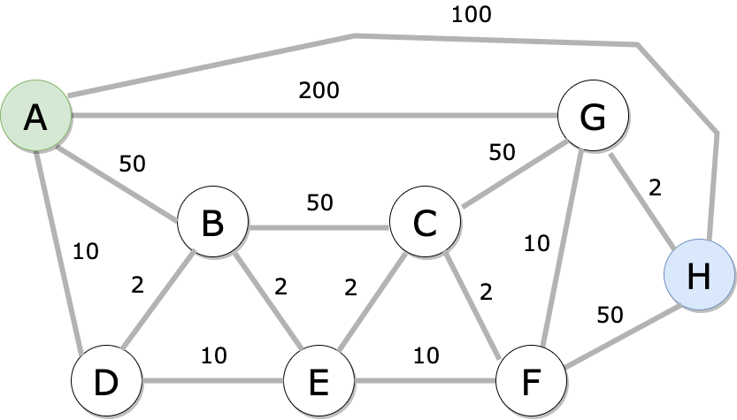

Part A – (10)

Use the Nearest Neighbor algorithm to find a path from node A to node B.

Part B – (20)

Use Dijkstra’s algorithm to find the shortest path from Vertex A -> Vertex H. Use the provided Table to show your work.

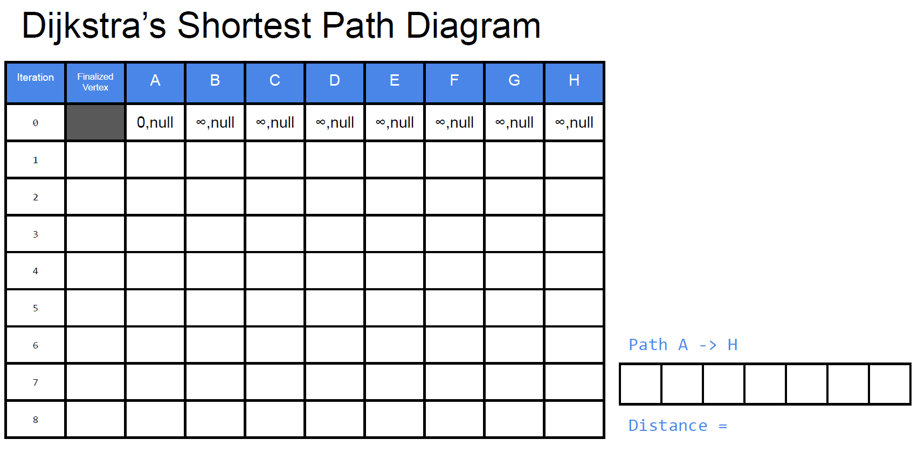

BONUS – Breadth First Path (5)

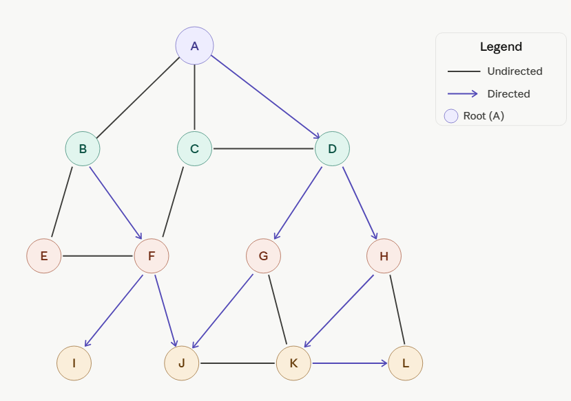
The graph above has 12 nodes (A–L) with a mix of directed (→) and undirected (–) edges.
Rules:
- Undirected edges may be traversed in either direction.
- Directed edges may only be followed in their stated direction.
- When multiple neighbors can be visited at the same time, visit them in alphabetical order.

Using Breadth-First Search starting from node A, find a path to node L.
a) List the nodes in the order they are first visited by BFS until L is reached.
b) Write the path returned by BFS from A to L.
Show your work below
Vertex | Predecessor

A to L

Path

